COVER PAGE PROJECT 1 B

NAME Olga Zimina

Lab Section number 301

Your initials are required below (Student Initials) certifying that the work submitted with this cover page is your own work, even if you have had help from me or other students. If you have used any documents provided by me, then you must state so in the Student Comments section below on this cover page and indicate what documents of mine you have used. If you do not use this cover page, I may not mark your submission.

OZ
(Student Initials)

Student Comments
=============================================================

This Project 1 contains:
- Project deliverables and instructions;
- Hierarchy chart and related Flowcharts;
- Program listing (COBOL executable form);
- Listing of the output file resulting from program execution;
- Screenshots for the entire application.

Please see next page to continue

Project deliverables and instructions

Deliverables for Project 1 will include the following:
- Prescribed Cover Page (refer to page 3 and 4 of this document)
- Hierarchy chart and related Flowcharts;
- Program listing (COBOL executable form)
- Listing of the output file resulting from program execution (use the print function in NOTEPAD, WORDPAD or WORD to print out the resulting file)
- Screen for one data record entry (screen capture)
You must use Cover Page provided at the end of this document.
E-mail your submission (as listed above) to me using the subject line CST8283 PROJECT 1

Your program should include comments for each of the modules indicating the basic function of the module (e.g. Prompt user for inventory record detail).

Please note your name on all documents handed in and in the AUTHOR statement within the IDENTIFICATION DIVISION.

PROBLEM

A file of inventory records is to be created from data entered at the keyboard (interactively). The record description and is given below.

Part Number 7 bytes numeric
Quantity on hand 4 bytes numeric;
Unit price 4 bytes numeric.

The output file will be called INVENT-FILE-OUT within the program and referred to as INVFILE.TXT on the external medium.

The record within the program will be referred to as INVENT-RECORD-OUT. There is to be no editing of the output record; it is to be written to the file exactly as input.
Use meaningful names for the data fields (elementary or group).

Processing Requirements
The program should:
- prompt the user for each field value to be entered (see Screen Spacing below);
- use the test data provided in Data Records below;
- prompt the user whether a record is to be entered (see Screen Spacing below);
- once a record is entered, the record should be written to the external file exactly as entered – no editing;

The prompt and data entry should follow the sequence noted below in Screen Spacing.
Screen Spacing
.
ELEMENT NAME/ query | PROMPT position | DATA entry position
Part Number | Line 4 col 5 | Line 5 col 10
Quantity on hand | Line 6 col5 | Line 7 col 10
Unit price | Line 8 col 5 | Line 9 col 10
Prompt for record entry | Line 16 col 10 | Line 17 col 10

Program control should depend on the user’s response to the prompt whether another record is to be entered.

Each prompt message to the user should briefly but clearly indicate the type of data or response required. (e.g. E nter Price, Record to enter ( Y or N).

Data Records
The data you must use for the program execution (test data) is contained in the table below.

Part number | Quantity on hand | Unit price
1111111 | 0150 | 0070
2222222 | 2000 | 0080
3333333 | 1000 | 0090

Hierarchy chart:

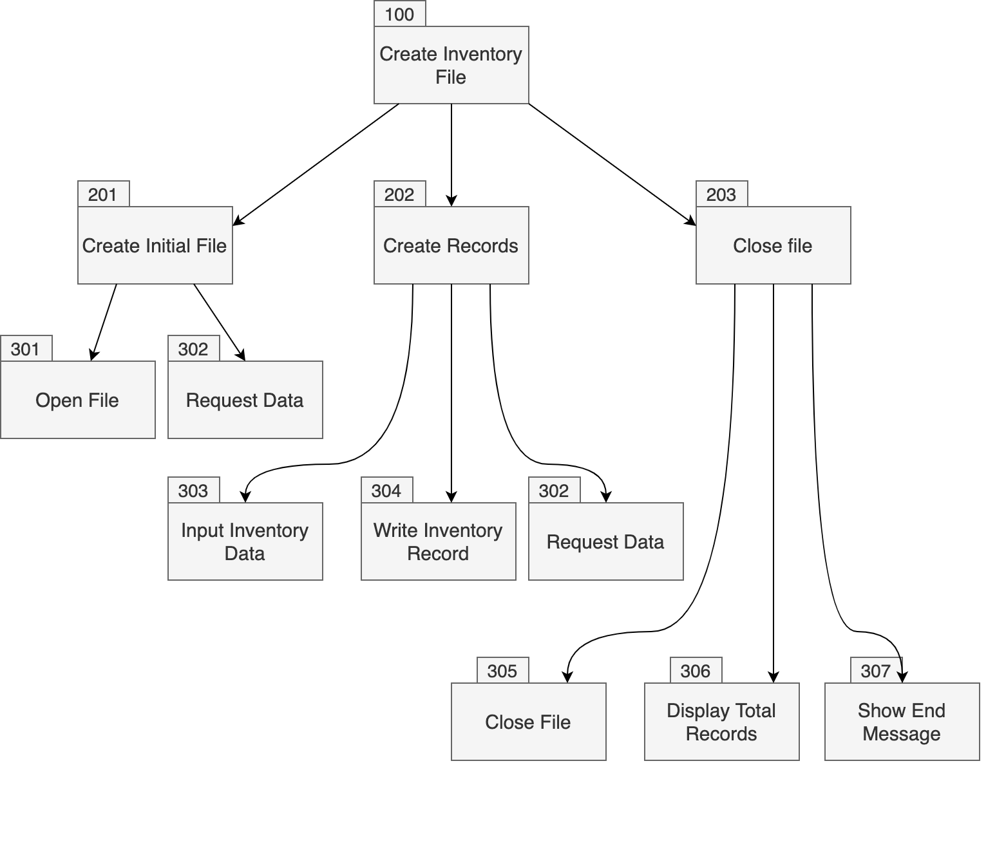

Flow charts:

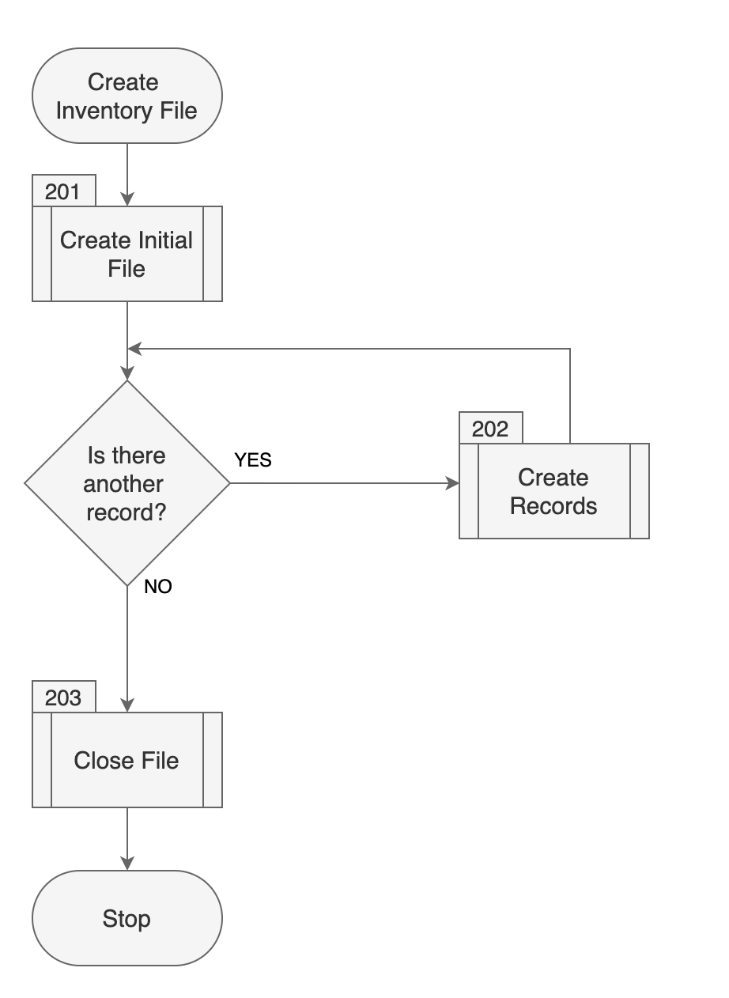

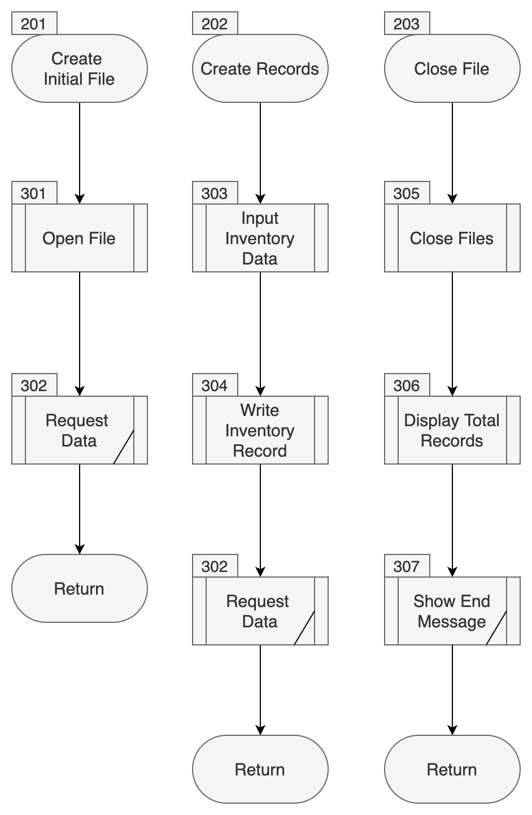

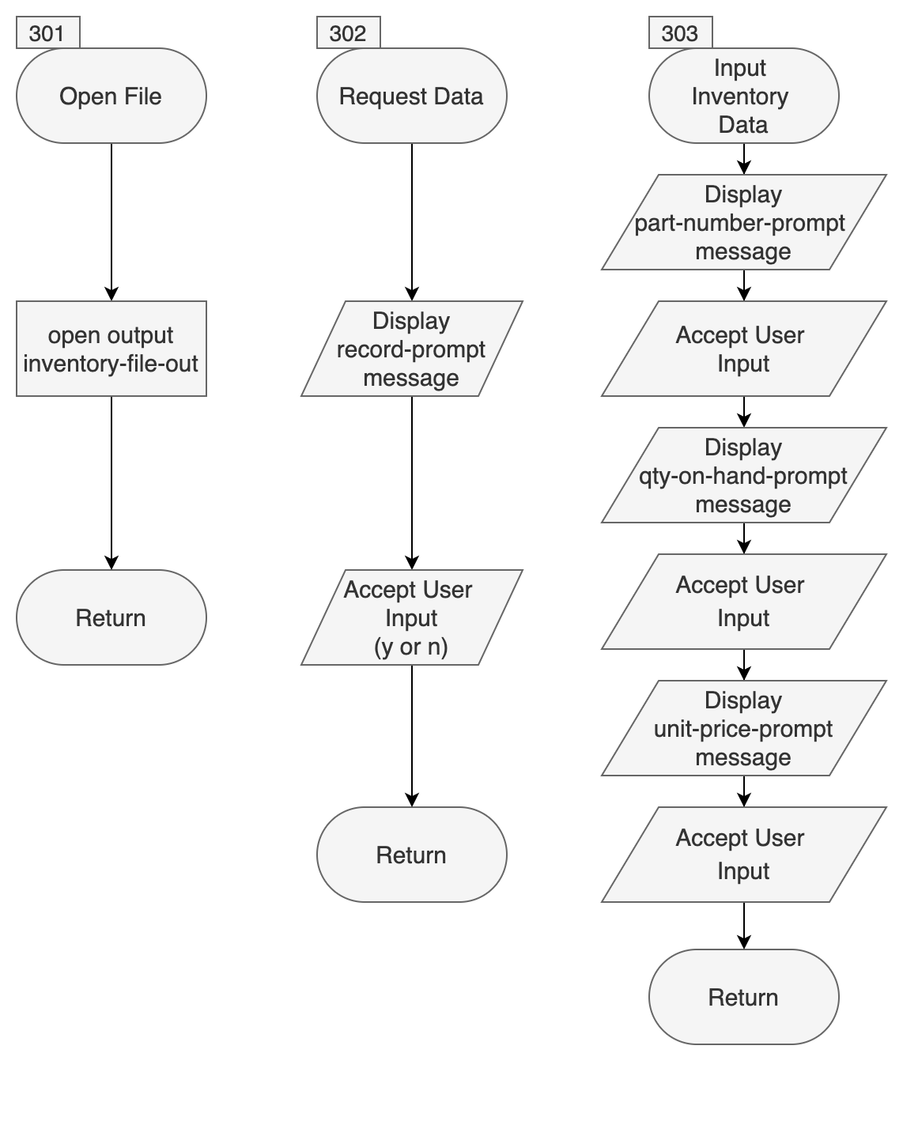

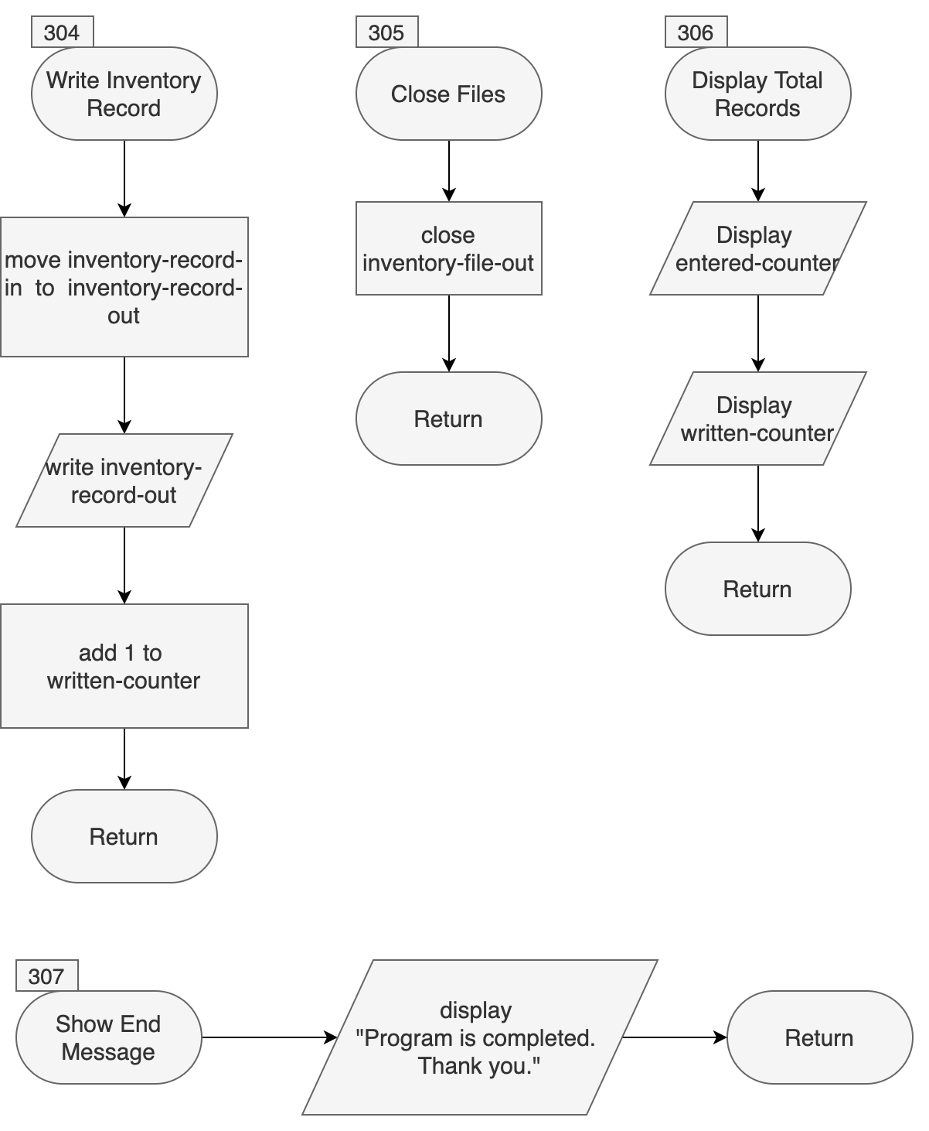

Program listing (COBOL executable form)

program-id. project1 as "CST8283 PROJECT1".
author. Olga Zimina - CST8283

environment division.
input-output section.
file-control.
select INVENTORY-FILE-OUT
assign to "D:\INVFILE.TXT"
organization is line sequential.

data division.
file section.
fd INVENTORY-FILE-OUT.
*----------------------------------------------------
* Variable to store data in file
*----------------------------------------------------
01 inventory-record-out pic 9(15).

working-storage section.
*----------------------------------------------------
* Variables to store data which user entered for the row
*----------------------------------------------------
01 inventory-record-in.
05 part-number-in pic 9(7).
05 qty-on-hand-in pic 9(4).
05 unit-price-in pic 9(4).

*----------------------------------------------------
* Messages which will be shown at the screen during
* program execution
*----------------------------------------------------
01 input-messages.
05 record-prompt pic x(46)
value "Do you have another record? Please use: y or n".
05 input-response pic x(1).
05 part-number-prompt pic x(29)
value "Please enter the part number:".
05 qty-on-hand-prompt pic x(34)
value "Please enter the quantity on hand:".
05 unit-price-prompt pic x(28)
value "Please enter the unit price:".

*----------------------------------------------------
* Variables to store amount of entered rows and saved rows
* They are incresed during program execution
*----------------------------------------------------
01 total-records.
05 entered-counter pic 9(2) value zero.
05 written-counter pic 9(2) value zero.

procedure division.
*----------------------------------------------------
* This is the entry point of the application and
* main block which manage the whole program context
*----------------------------------------------------
100-create-inventory-file.
perform 201-create-initial-file.
perform 202-create-records
until input-response = "n".
perform 203-close-file.

stop run.

*----------------------------------------------------
* This block is responsible for opening file/create
* if not exists, and showing the screen with a question
* whether a new record should be added or not
*----------------------------------------------------
201-create-initial-file.
perform 301-open-files.
perform 302-request-data.

*----------------------------------------------------
* This block takes user input for each of the data entry
* which needs to be put into the row and then saves
* data into the file
*----------------------------------------------------
202-create-records.
perform 303-input-inventory-data.
perform 304-write-inventory-record.
perform 302-request-data.

*----------------------------------------------------
* Final block closing open file with recorded data and
* displaying the amount of enetered records and
* saved records into the file
*----------------------------------------------------
203-close-file.
perform 305-close-files.
perform 306-display-total-records.
perform 307-end-message.

*----------------------------------------------------
* Low level block to open file
*----------------------------------------------------
301-open-files.
open output inventory-file-out.

*----------------------------------------------------
* Displaying a question about the next row and accept user input
*----------------------------------------------------
302-request-data.
display record-prompt
line 12 column 5.
accept input-response
line 13 column 5.

*----------------------------------------------------
* Displaying each entry for data and accept user input
* Also increases the counter of rows added
*----------------------------------------------------
303-input-inventory-data.
initialize inventory-record-in.
display part-number-prompt line 4 column 5 with blank
screen.
accept part-number-in line 5 column 10.

display qty-on-hand-prompt line 6 column 5.
accept qty-on-hand-in line 7 column 10.

display unit-price-prompt line 8 column 5.
accept unit-price-in line 9 column 10.

add 1 to entered-counter.

*----------------------------------------------------
* Move the value of the previously grabbed row to
* another variable which should be outputted to the
* file and write it down to the file.
* Also increases the counter of rows written
*----------------------------------------------------
304-write-inventory-record.
move inventory-record-in to inventory-record-out.
write inventory-record-out.
add 1 to written-counter.

*----------------------------------------------------
* Close opened file
*----------------------------------------------------
305-close-files.
close inventory-file-out.

*----------------------------------------------------
* Output to the screen the amount of entered rows
* and amount of rows has been written to data file
*----------------------------------------------------
306-display-total-records.
display "Entered: " line 4 column 5 with blank screen
display entered-counter line 4 column 17.
display "Written:" line 5 column 5.
display written-counter line 5 column 17.

*----------------------------------------------------
* Displays the final message
*----------------------------------------------------
307-end-message.
display "Program is completed. Thank you." line 7 column 5
display "" line 8 column 4.
goback.

end program project1.

Listing of the output file resulting from program execution

111111101500070
222222220000080
333333310000090

Screenshots for the entire application

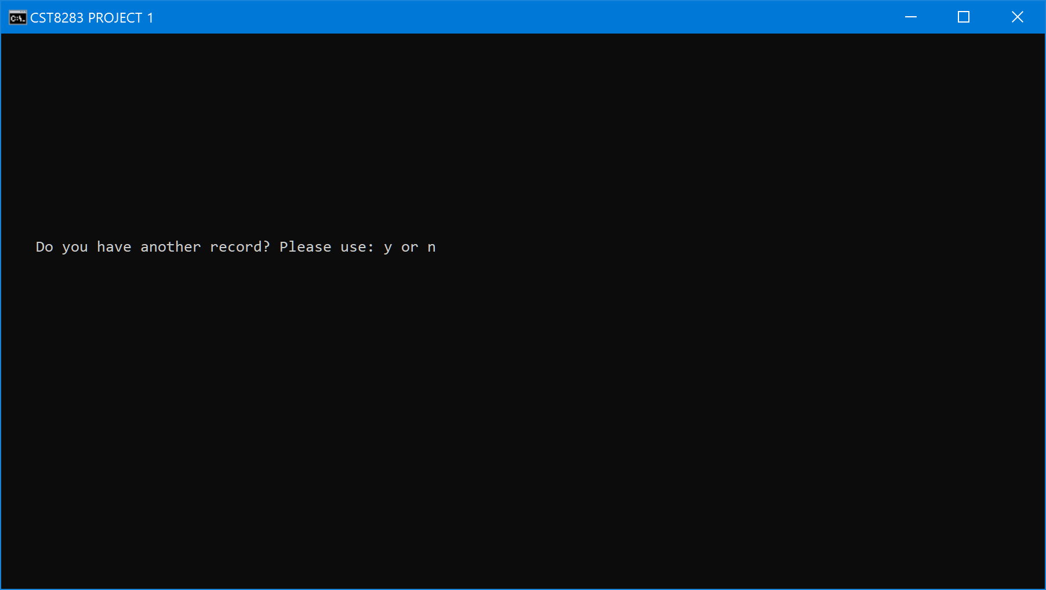

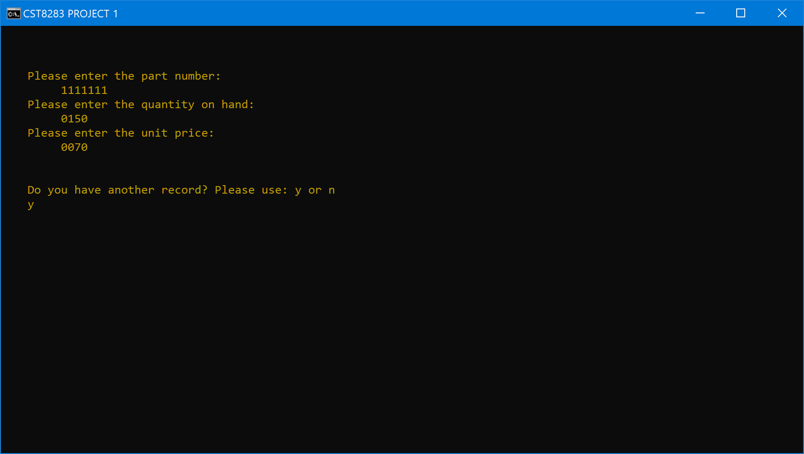

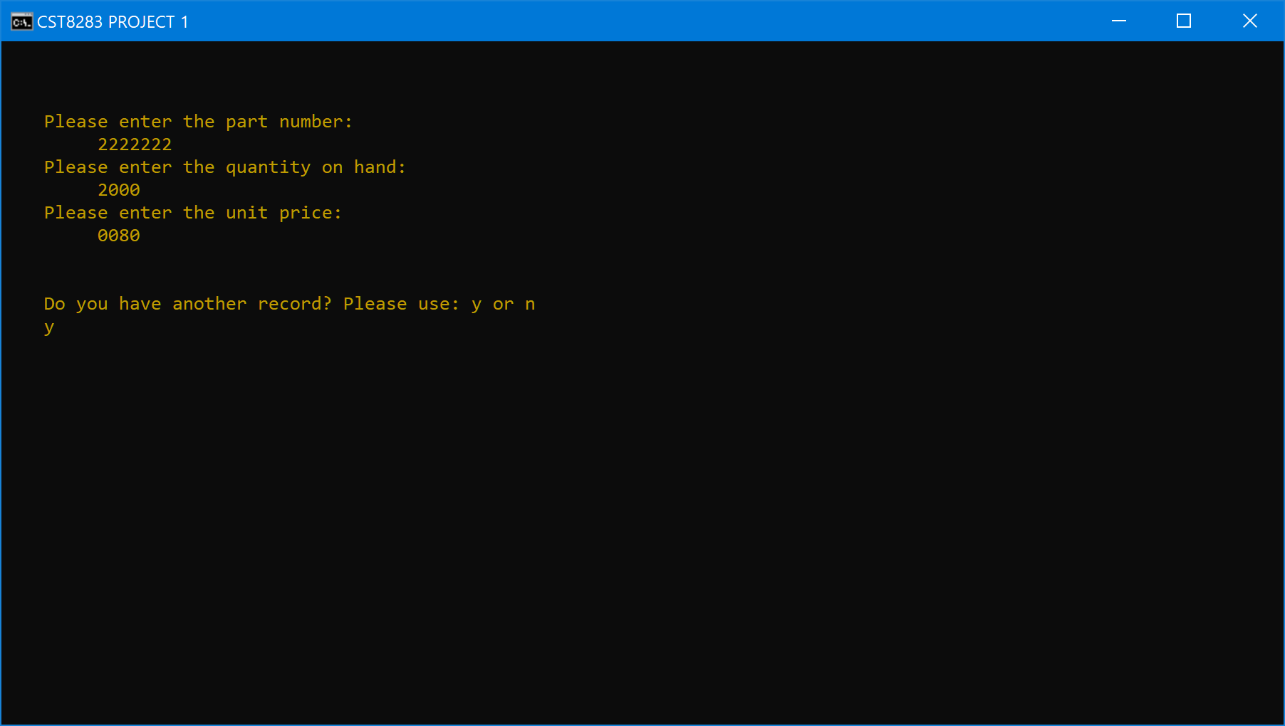

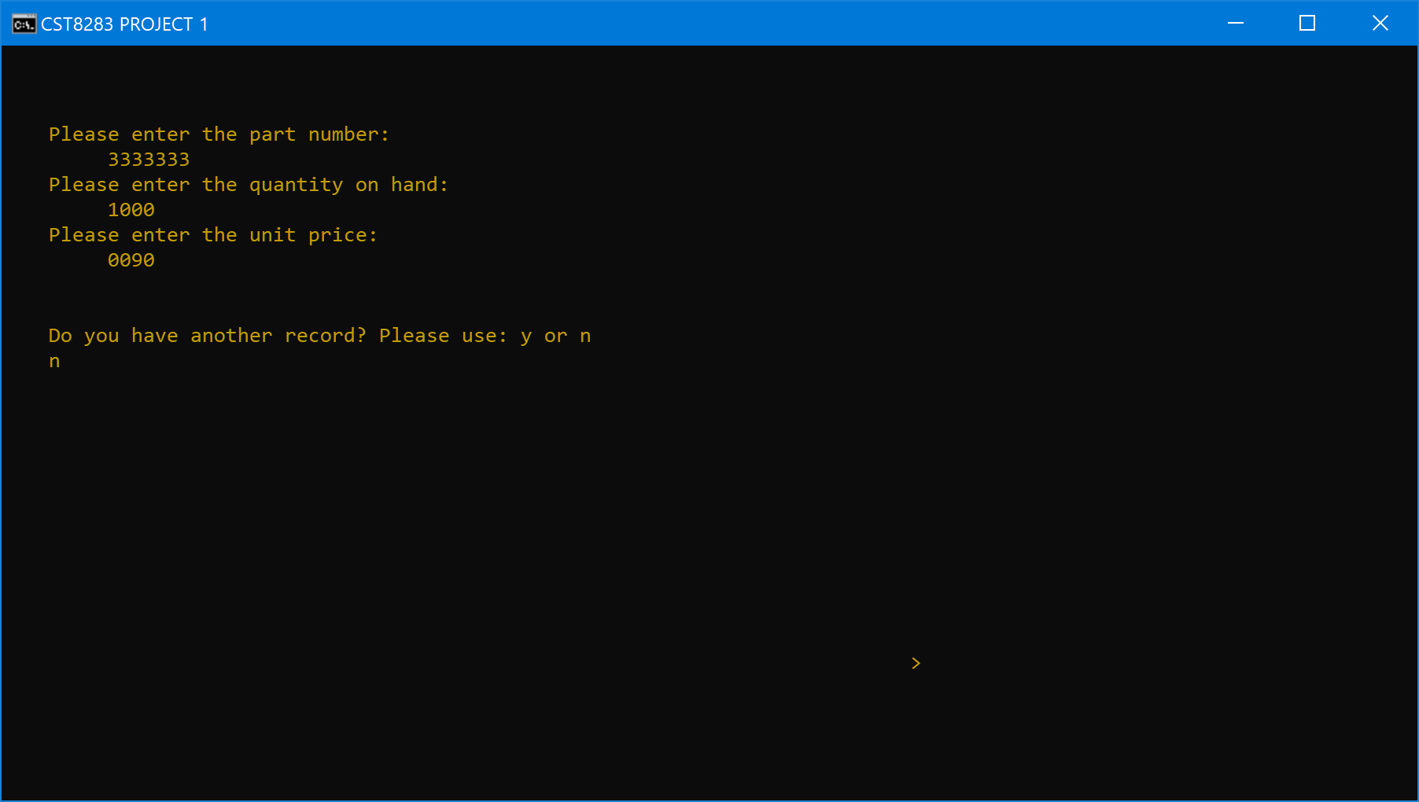

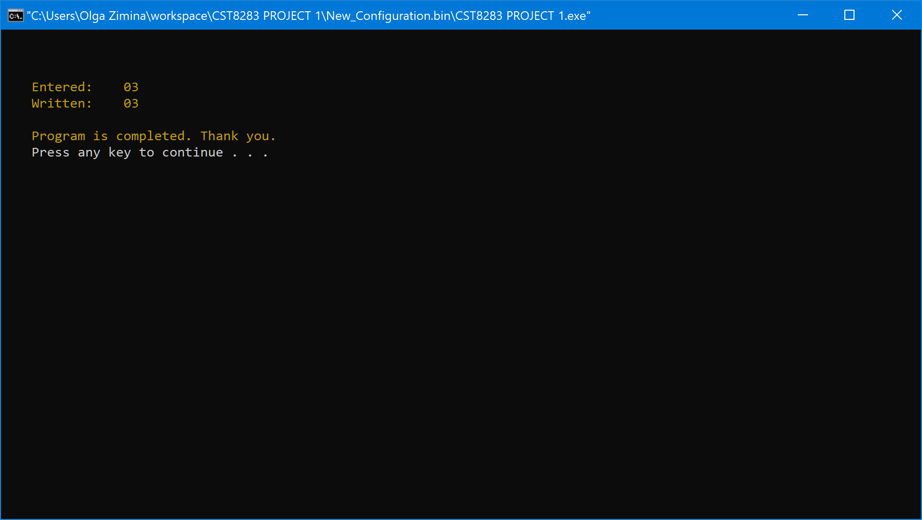

=============================================================
Marking Scheme (as applicable)
The project will be marked out of 100% using the following breakdown.

Refer to Notes regarding grading below for specific points that will be checked and influence the marks allocated.

Output format and content ___ / 20

Program listing ___ / 50

Documentation ___ / 30

TOTAL ____ / 100

Comments / feedback (to be made by instructor)

__________________________
Signature (Mel Sanschagrin)

Notes regarding grading
The program listing will be examined primarily for:
- relationship to function chart and flowchart;
- use of prescribed commands;
- application of standards and structures;
- proper functional constructs (cohesion and coupling);
- internal comments.

The output reports (hard copy or screen display) will be examined for accuracy of the output information and the prescribed format.

The documentation will be examined to ensure:
- proper use of symbols (flowcharts);
- proper structure and content of structure/function/hierarchy charts;
- clear and accurate report or screen layouts (if required);
- clear description or comments of the program logic.

